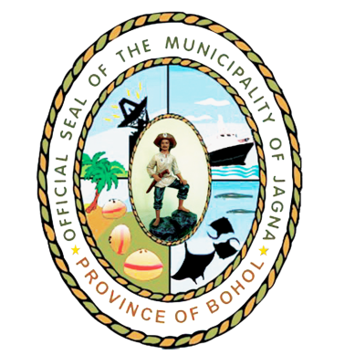

Republic of the Philippines
PROVINCE OF BOHOL
Municipality of JAGNA

BIDS AND AWARDS COMMITTEE

: (038) 531-8005/0917-7020979

http://sites.google.com/site/mpdcjagna/bidsandawardscommittee

Email: bac_jagnabohol@yahoo.com

MS. BRIGIDA B. ACERON
BAC Chairman

ENGR. JOSEFINA S. RAŇOA
BAC Vice Chairman

MR. RAYMOND F. CUADRA
BAC Member

MS. EFRENA A. BUENAFE
BAC Member

MS. MA. LOVELLA E. ACEBES
BAC Member

ENGR. DIOSDADA E. RAŇISES
BAC Member

ENGR. GERRY V. ARANETA
BAC Head Secretariat

MS. RIZEAN T. OLIVAR
BAC Secretary

May 24, 2010

Messieurs/Mesdames:

The Bids & Award Committee will schedule the opening of submitted bid proposals of the participating bidders for the “Delivery of PE Pipes for the Rehabilitation of Jagna Waterworks System”, to be held on June 1, 2010 Tuesday at 10:00 o’clock in the morning at Capt. Goyo Caseñas Hall. Please be guided accordingly.

BAC SECRETARIAT

