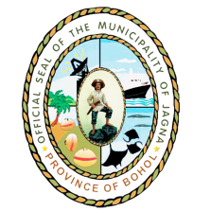
Republic of the Philippines
Province of Bohol
Municipality of JAGNA

OFFICE OF THE MAYOR

Tel. No. (038) 531-8001 *Telefax No. (038) 2382-845

CERTIFICATION

This is to certify that during my official travel to __Manila__, on __October 4,5 and 23, 2014___ for the following purpose:

To attend and participate to Pre-departure Orientation of JICA’s Training Program for Young Leaders under the Rural Development Course.

I have actually incurred Hotel Accommodation, in the amount of ____Four Thousand Ninety Pesos_____ (P _4,090.00__ )

This certification is issued to support my liquidation for the said travel.

IN WITNESS WHEREOF, I have hereunto affix my signature this __27th day__ of _October 2014___ at Jagna, Bohol, Philippines.

GERRY V. ARANETA
MPDC

Approved:

ATTY. FORTUNATO R. ABRENILLA
Municipal Mayor

