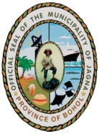
Republic of the Philippines
Province of Bohol
Municipality of JAGNA

MUNICIPAL DEVELOPMENT COUNCIL
www.jagna.gov.ph (038) 531-8005
__________________________________________________________________________________________

